Exercise 1: Ranking and Window Functions
Query-1 using ROW_NUMBER()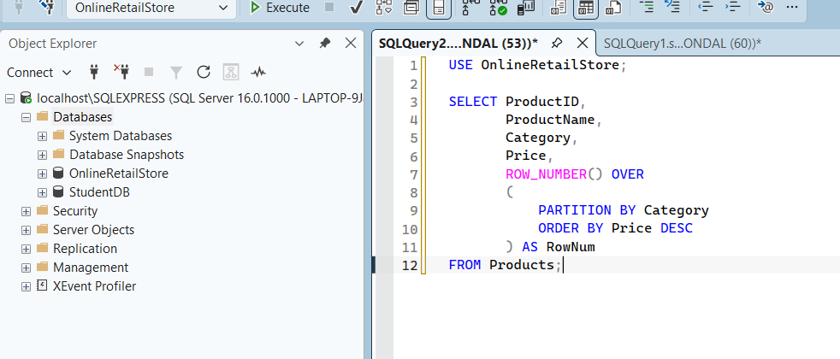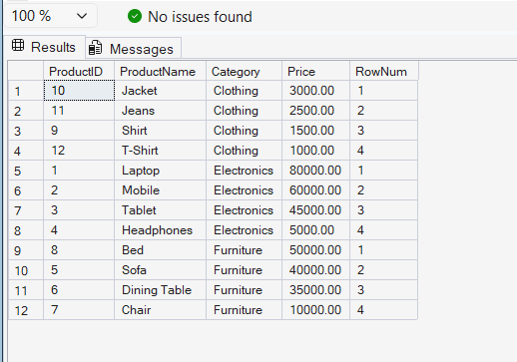

Query 2 Using Rank()
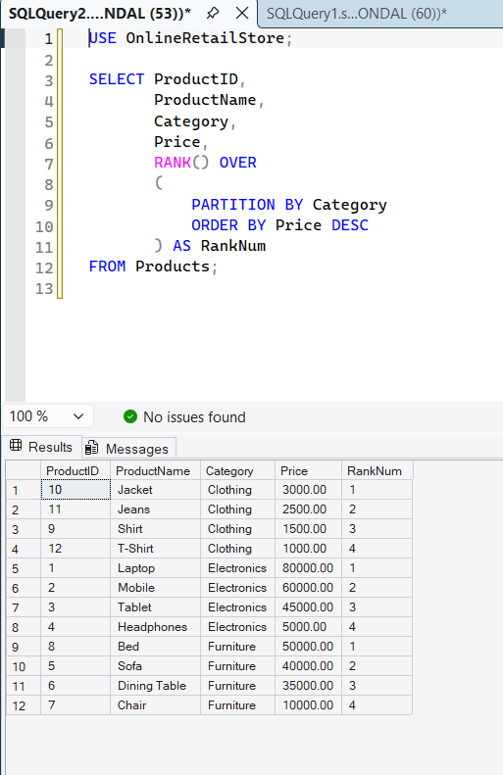

Query 3 DENSE_RANK()
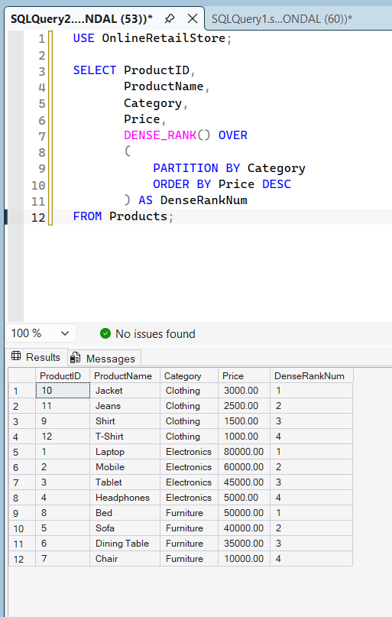

Final Query (Top 3 Products From Each Category)
